A Data Analysis Report On

“SHOPNEST STORES SALES”

As a fulfilment of
CAPSTONE PROJECT

(POWER BI)

Submitted By:

SHIVANAND.KONDAGULI

Submitted to:

TEAM SKILLOVILLA


ABSTRACT

Introduction:
ShopNest is the leading department store on e-commerce marketplaces in Portugal, acting as a vital bridge that connects small businesses from diverse regions to online platforms. In today’s fast-paced business landscape, data analytics plays a crucial role in improving decision-making and boosting operational efficiency.

Purpose of the Analysis:
This project aims to explore ShopNest’s operations through data analytics, with the goal of uncovering insights that fuel business growth and operational optimization. By harnessing the power of data, the project strives to deliver actionable recommendations that enhance decision-making and improve overall efficiency.

Scope of the Analysis:
This project covers a wide array of analyses, including—but not limited to—identifying top categories by total revenue, examining delayed orders, comparing monthly trends in delayed vs. on-time orders, analyzing payment methods, evaluating product ratings, assessing state-wise sales distribution, identifying seasonal sales patterns, and conducting a comprehensive revenue analysis. Each of these analyses offers valuable insights into different facets of ShopNest’s operations, contributing to a well-rounded understanding of its performance in the e-commerce landscape.

Expected Outcomes:
The anticipated outcome of this project is to deliver valuable insights and strategic recommendations that enable ShopNest to optimize its operations, improve the customer experience, and drive sustainable business growth. By leveraging data-driven insights, ShopNest will be better equipped to make informed decisions that support its ongoing success in the competitive e-commerce landscape.

Contents
ABSTRACT 2
TOP CATEGORIES BY TOTAL PRICE 4
DELAYED ORDERS ANALYSIS 5
MONTHLY COMPARISON OF DELAYED AND ON-TIME ORDERS 6
PAYMENT METHOD ANALYSIS 7
PRODUCT RATING ANALYSIS 8
STATE-WISE SALES ANALYSIS 10
SEASONAL SALES PATTERN 12
REVENUE ANALYSIS 13
CONCLUSION 14

TOP CATEGORIES BY TOTAL PRICE

Question Statement :
Identify and visually represent the top 10 product categories by total sales

Visualization :
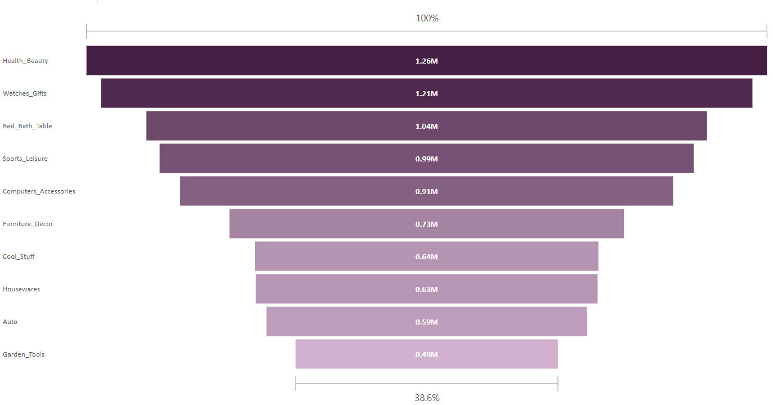

Explanation :
The Funnel chart highlights the top 10 product categories by total sales, offering key insights into ShopNest’s revenue distribution. Leading the chart is Health & Beauty (beleza_saude) with $1.26 million in sales, followed closely by Watches & Gifts (relogios_presentes) at $1.21 million, and Bed, Bath & Table (cama_mesa_banho) with $1.04 million. Other strong performers include Sports & Leisure (esporte_lazer) and Furniture & Décor (informatica_acessorios), each generating over $0.9 million in sales. Further down the chart, Garden Tools (ferramentas_jardim) and Automotive (automotivo) record sales of $0.49 million and $0.59 million, respectively.
This visualization emphasizes the importance of these top-selling categories, offering critical insights for strategic planning and resource allocation. Understanding which categories drive the most revenue enables ShopNest to:
- Refine product offerings to match consumer demand
- Design targeted marketing campaigns for high-performing segments
- Optimize inventory and supply chain decisions
- Enhance customer engagement by focusing on popular categories
By acting on these insights, ShopNest can strengthen its market position, increase profitability, and supportlong-term business growth.

DELAYED ORDERS ANALYSIS

Question Statement :
Determine the number of delayed orders in each category. An order is considered delayed if the actual delivery date is later than the estimated delivery date.

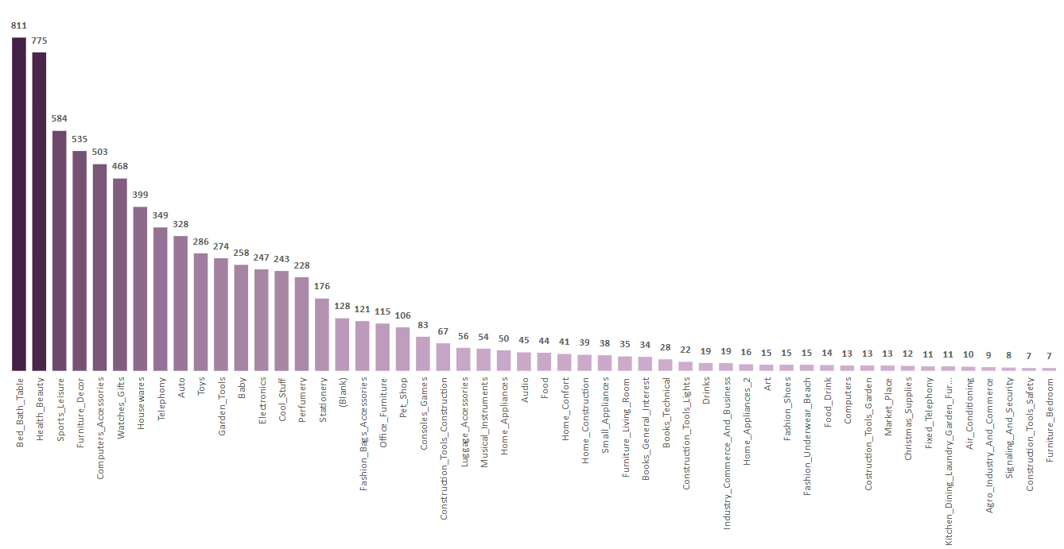
Visualization :

Explanation :
The bar chart offers a detailed analysis of delayed orders across various product categories, shedding light on key aspects of sales performance and fulfilment efficiency.
"Bed, Bath & Table" leads with the highest number of delayed orders at 811, signalling potential issues in logistics or inventory handling within this category. Close behind are "Health & Beauty" with 775 delays and "Sports & Leisure" with 584, both suggesting a need for improved coordination across supply chain and fulfilment operations.
Additional categories showing high delays include:
- "Furniture & Décor" – 535 delayed orders
- "Computers & Accessories" – 503 delayed orders
- "Watches & Gifts" – 468 delayed orders
These figures may reflect systemic inefficiencies such as poor inventory visibility, vendor delays, or fulfilment backlogs.
In contrast, categories like "Diapers & Hygiene" and "Flowers" show exceptional performance, each recording only 1 delayed order, highlighting effective fulfilment processes and possibly localized or simpler supply chains.
This analysis is instrumental in:
- Identifying operational bottlenecks across high-delay categories
- Prioritizing improvements in logistics, warehousing, and vendor management
- Allocating resources strategically to areas with the greatest fulfilment challenges
- Improving customer satisfaction by reducing delays in high-demand segments
For example, moderate delays in "Home Appliances" (50 orders) and "Electronics" (247 orders) suggest opportunities to enhance inventory forecasting, order tracking, and replenishment planning to reduce friction and meet delivery expectations more consistently.

Overall, the visualization acts as a crucial tool for data-driven decision-making, empowering ShopNest to fine-tune its operations, reduce delivery delays, and enhance the customer experience in a competitive e-commerce environment.

MONTHLY COMPARISON OF DELAYED AND ON-TIME ORDERS

Question Statement :
Create a dynamic visual that compares the number of delayed orders to the number of orders received earlier for each month. Utilize the drillthrough cross-report feature to provide a detailed analysis of late and on-time deliveries.

Visualization :
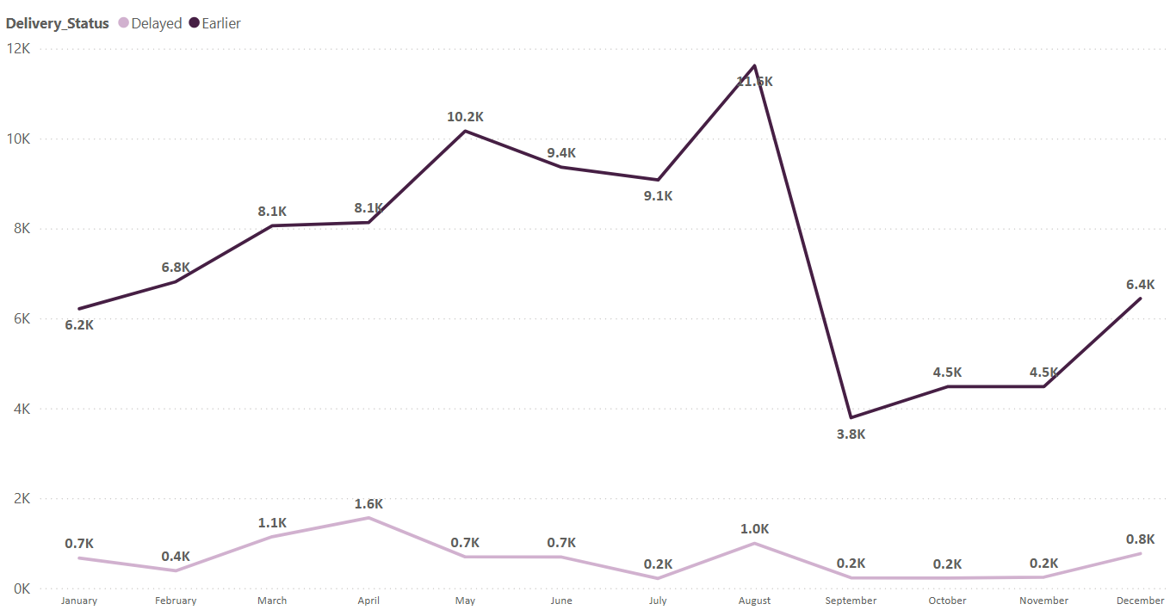

Explanation :
The line chart presents a comprehensive month-by-month comparison of delayed versus earlier (on-time) orders, offering key insights into ShopNest’s order fulfillment performance throughout the year.
August stands out as the top-performing month, with 11,620 earlier orders and only 996 delayed orders, indicating exceptional operational efficiency and customer service responsiveness. On the other hand, July records the narrowest gap, with 9,078 earlier orders and 216 delayed orders, still demonstrating a solid fulfillment rate but with a slightly higher proportional delay.
Other months follow a similar positive trend:
- September: 3,790 earlier vs. 231 delayed
- October: 4,480 earlier vs. 222 delayed
- November: 4,483 earlier vs. 245 delayed
These figures highlight ShopNest’s consistent ability to fulfill orders promptly across much of the year.
However, December and January show an uptick in delays, with 767 and 667 delayed orders, respectively—likely a result of increased demand and logistical strain during the holiday season. In contrast, May and June maintain strong performance, with relatively low delays of 696 and 691 respectively, suggesting effective inventory planning and operational readiness during those months.

Key Takeaways:
- Strong months (e.g., August) demonstrate best practices in fulfilment that can be scaled across the year.
- Peak season months (December, January) may benefit from enhanced planning, increased staffing, or improved logistics to reduce delays.
- Consistent performance in other months reinforces overall operational reliability.
By analyzing these patterns, ShopNest can:
- Optimize staffing and logistics during peak demand periods
- Implement proactive measures such as early promotions or staggered shipping during high-traffic months
- Allocate resources more effectively to ensure balanced performance throughout the year
Overall, this visualization empowers ShopNest to fine-tune its fulfilment strategy, reduce delays, and enhance customer satisfaction, ultimately supporting long-term customer loyalty and business growth.

PAYMENT METHOD ANALYSIS

Question Statement :
Analyze the most frequently used payment methods by customers using a visually appealing representation, such as a pie chart or other suitable visuals.

Visualization :
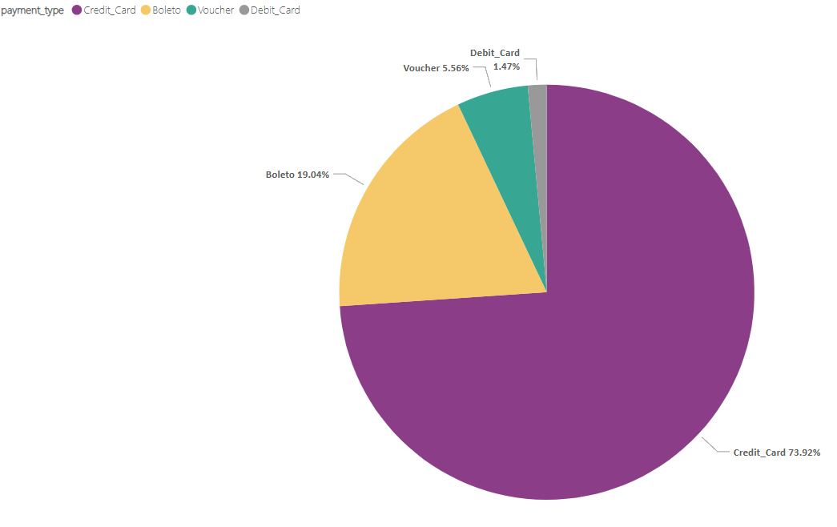

Explanation : The pie chart offers a succinct overview of payment types and their distribution among customers, providing key insights into transaction preferences.

Credit card emerges as the most popular payment method, with 76,795 customers opting for this mode of payment, constituting the majority of transactions and representing approximately 73.9% of the customer base. Boleto follows as the second most preferred payment type, with 19,784 customers choosing this method for their purchases, accounting for around 19.0% of the total customers.
Additionally, voucher and debit card transactions are represented by 5,775 and 1,529 customers respectively, indicating a smaller yet significant portion of the customer base utilizing these payment options, representing approximately 5.6% and 1.5% of customers respectively. Overall, the visualization highlights the dominance of credit card payments, suggesting a preference for convenience and flexibility among customers.

Furthermore, the pie chart underscores the importance of offering diverse payment options to cater to varying customer preferences and needs. While credit card transactions dominate, the presence of boleto, voucher, and debit card payments indicates the significance of providing alternative payment channels to accommodate different customer demographics and preferences. Additionally, the visualization serves as a valuable tool for decision-makers to allocate resources effectively, prioritize payment processing enhancements, and enhance overall transaction efficiency to meet evolving customer demands and preferences.

PRODUCT RATING ANALYSIS

Question Statement :
Determine the top 10 highest-rated products and the bottom 10 lowest-rated products using a bar or column chart.

Visualization : Top 10 Highest Rated Products 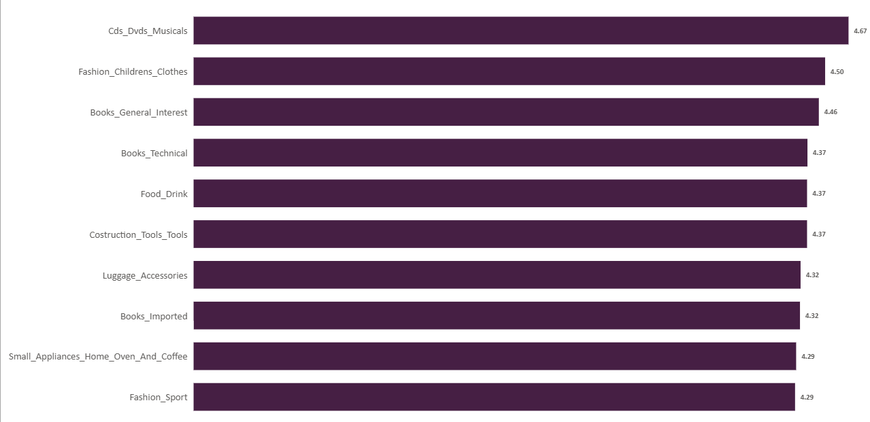

Bottom 10 Least Rated Products
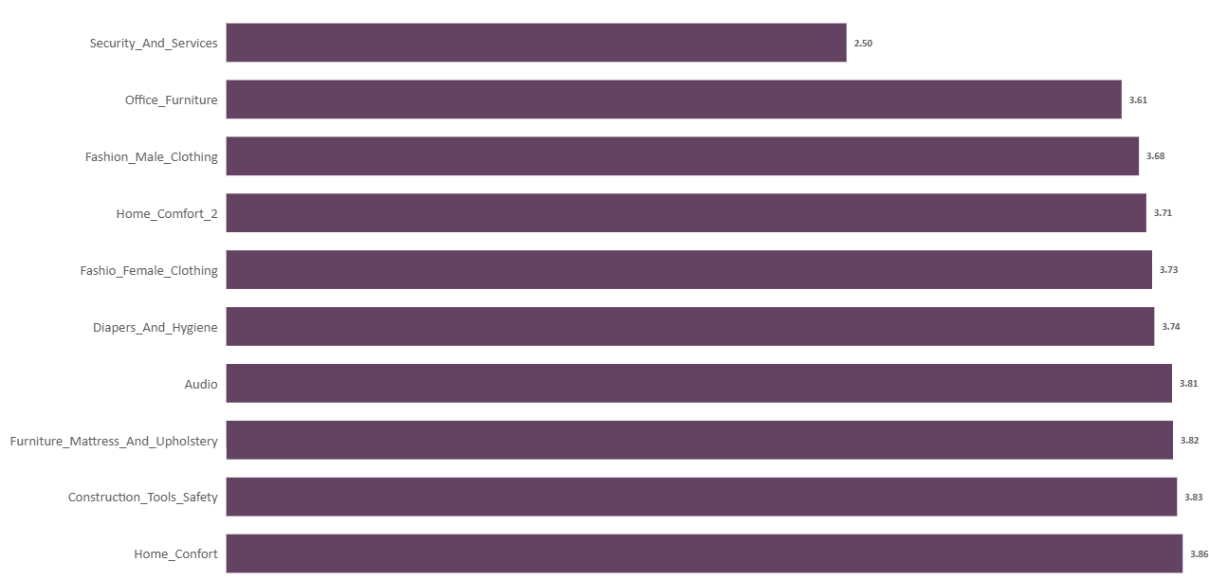

Explanation :
The bar chart provides a clear overview of the top 10 highest-rated product categories, based on average customer ratings, offering meaningful insights into customer satisfaction and preferences across ShopNest’s product range.
At the top of the list is "CDs, DVDs, and Musicals" with an outstanding average rating of 4.67, reflecting exceptional customer satisfaction and possibly niche, high-quality offerings. "Fashion - Children's Clothes" and "Books - General Interest" follow closely with average ratings of 4.50 and 4.46, indicating strong product appeal and positive customer experiences in these categories.
Other highly rated categories include:
- "Books - Technical", "Food & Drink", and "Construction Tools" – each with an average rating of 4.37
- "Small Appliances (Home, Oven, and Coffee)" and "Fashion - Sport" – both earning solid ratings of 4.29
Also featured in the top 10 are "Books - Imported" and "Luggage & Accessories", highlighting consumer interest in premium and specialized products.
Key Insights:
- High ratings reflect strong product quality, reliability, and customer experience.
- Categories like children’s fashion, sportswear, and home appliances underscore the importance of functionality, design, and performance in consumer choices.
- The presence of books (both general and technical) in the top rankings points to a continued demand for educational and leisure content, often associated with high product satisfaction.
Strategic Implications:
- Refine and expand high-performing product lines to maintain and grow customer satisfaction.
- Leverage positive feedback from top-rated categories in marketing and branding efforts.
- Use insights to prioritize inventory, improve supplier relationships, and guide product development.
- Consider deeper investment in categories like imported books and luggage, where specialized interest may translate into higher margins and customer loyalty.
In summary, this visualization is a powerful tool for understanding customer sentiment. By focusing on categories that consistently deliver high satisfaction, ShopNest can better align its offerings with customer expectations, strengthen its market position, and drive long-term business growth.

STATE-WISE SALES ANALYSIS

Question Statement :
Identify and visually represent states with high and low sales, providing a clear understanding of regional sales performance.

Visualization :
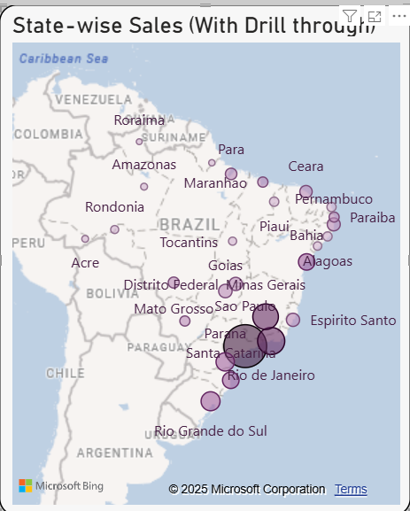

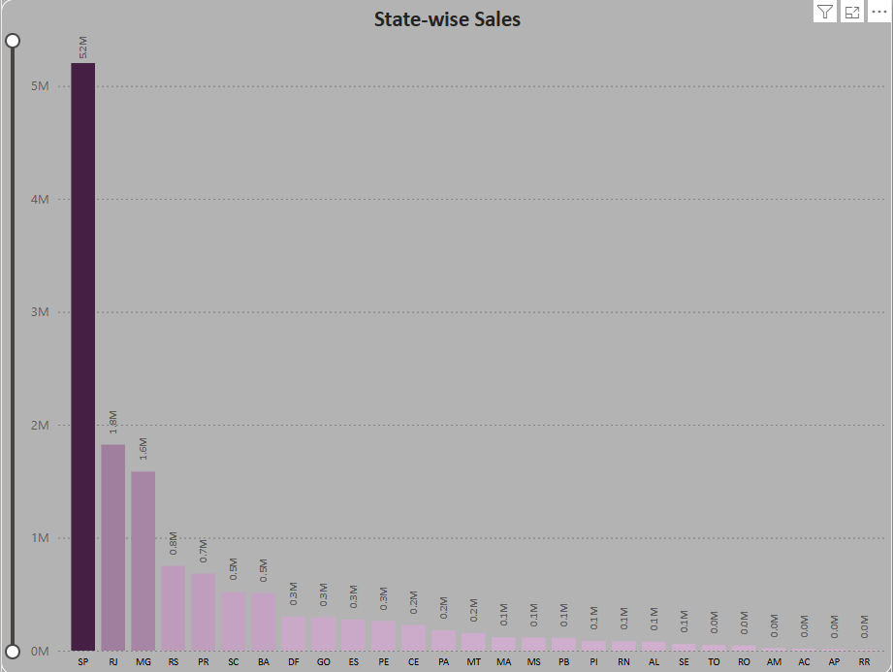

Explanation :
- The map chart provides an in-depth visual representation of sales distribution across various Brazilian states, offering a geographic perspective on revenue performance and regional market penetration.
- São Paulo (SP) emerges as the clear leader in sales performance, contributing over $5.20 million in revenue, which constitutes an impressive 38.3% of ShopNest’s total sales. This highlights the state's dominant role in the national e-commerce landscape, likely driven by its dense population, advanced infrastructure, and high consumer spending capacity.
- Rio de Janeiro (RJ) follows as the second-highest revenue-generating state, with approximately $1.82 million in sales, accounting for 13.4% of total sales. This strong performance underscores the importance of RJ as a key urban market with significant e-commerce activity.
- Other states also demonstrating notable sales figures include:
- Minas Gerais (MG), with sales around $1.59 million, contributing 11.7% of the total revenue.
- Rio Grande do Sul (RS), with approximately $0.75 million, making up 5.5% of total sales.
These states reflect healthy consumer demand and active market engagement, representing important areas for continued investment and growth.
- On the other end of the spectrum, several states show significantly lower sales performance:
- Roraima (RR) reports sales of just $0.007 million.
- Amapá (AP) follows closely with $0.013 million in revenue.
These states each contribute less than 0.1% to ShopNest's total revenue, highlighting underdeveloped or underserved markets with potential for future expansion.
- The map’s gradient color scale effectively categorizes states into high, medium, and low sales brackets. This visual distinction allows for quick identification of performance clusters and regional disparities, providing actionable insights at a glance.
- The visualization serves multiple strategic purposes:
- It underscores the critical role of major states like São Paulo and Rio de Janeiro in sustaining overall business performance.
- It identifies opportunities for targeted growth in low-performing regions, where investment in marketing, logistics, and localized strategies could stimulate demand.
- It supports data-driven decision-making related to regional resource distribution, inventory planning, and delivery optimization.
- By leveraging these insights, ShopNest can:
- Strengthen its presence in high-performing areas through deeper customer engagement and tailored offerings.
- Explore untapped potential in underserved states by adapting its go-to-market strategies.
- Enhance overall national market coverage and ensure a more balanced, inclusive approach to growth.

SEASONAL SALES PATTERN

Question Statement :
Investigate and visualize any seasonal patterns(Quarterly) or trends in sales data over the course of the year.

Visualization :
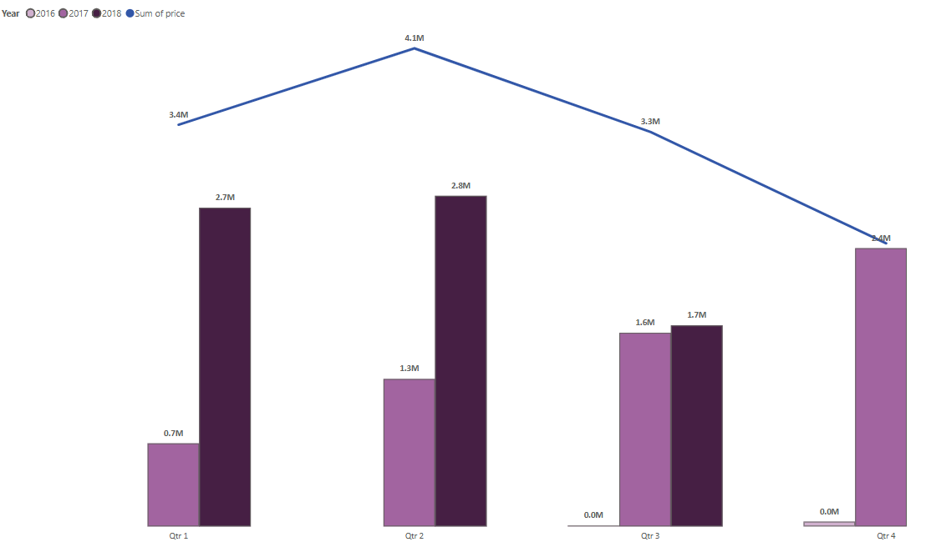

Explanation :

The combo chart offers a detailed view of quarterly sales performance across multiple years, providing key insights into both growth trends and seasonal sales behaviour.
The bar charts represent sales figures by year and quarter, clearly highlighting an upward trend across all quarters. For example, Q1 sales rose significantly from $0.71 million in 2017 to $2.7 million in 2018, demonstrating strong year-over-year growth. Similarly, Q2 sales increased from $1.25 million to $2.81 million during the same period, reflecting expanding market demand. The line chart overlays total sales for each quarter, offering a consolidated view of overall performance over time.
In addition to growth trends, the chart also reveals seasonal sales patterns. Historically, the second quarter (Q2) records the highest cumulative sales at $4.1 million, followed by Q1 ($3.4 million) and Q3 ($3.3 million). These patterns highlight the importance of seasonal planning and resource allocation to leverage peak demand periods while maintaining steady performance year-round.
Overall, the combo chart serves as a powerful tool for understanding long-term sales dynamics. It enables businesses to identify growth opportunities, anticipate seasonal fluctuations, and optimize sales strategies to support sustainable success.

REVENUE ANALYSIS

Question Statement :
Determine the total revenue generated by ShopNest Store and analyze how it changes over time(Yearly). Represent this information through suitable visuals to highlight trends and patterns.

Visualization :
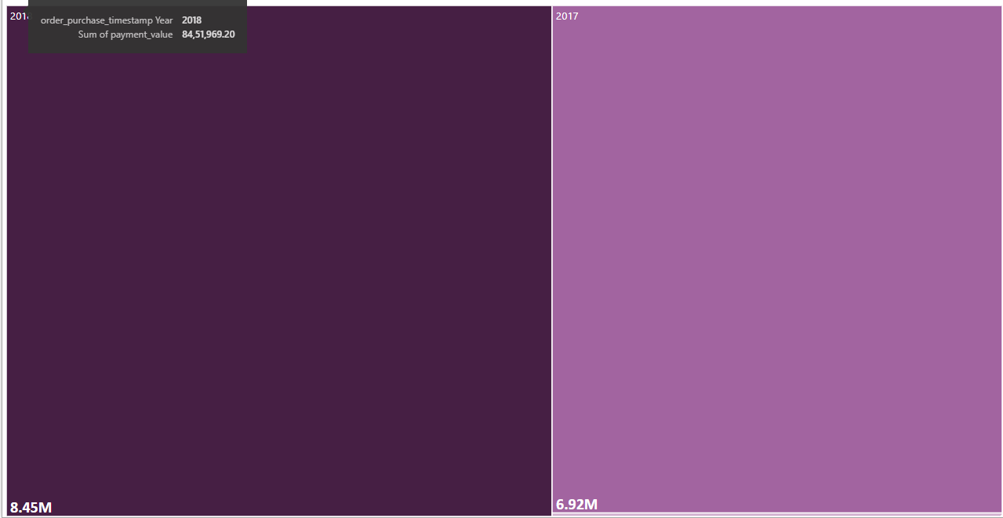

Explanation :

The tree chart visually illustrates revenue trends over multiple years, revealing key insights into the organization’s financial growth.
A particularly notable shift occurs between 2016 and 2017, where revenue jumps dramatically from $47,000 to $6.92 million. This sharp increase reflects a major growth phase, driven by favorable market conditions and effective strategic initiatives.
The upward trajectory continues into 2018, with revenue rising further to $8.45 million, signaling ongoing business momentum and successful adaptation to evolving market demands. This consistent growth demonstrates the organization's strong performance in identifying opportunities, scaling operations, and sustaining revenue expansion over time.

CONCLUSION

- Regional Sales Performance
State-wise sales analysis highlights that regions like São Paulo and Rio de Janeiro are major contributors to overall revenue. Focusing strategically on these high-performing markets, while exploring growth opportunities in underperforming regions, can significantly boost overall sales.

- Fulfilment Efficiency
The review of delayed orders uncovers potential logistics and supply chain challenges. Streamlining fulfilment processes and resolving systemic inefficiencies will enhance operational effectiveness and improve customer satisfaction.

- Seasonal Sales Trends
Clear seasonality trends across quarters underscore the need for proactive planning. Capitalizing on peak periods through optimized resource allocation and targeted campaigns can drive consistent growth throughout the year.

- Payment Method Preferences
Credit cards remain the most preferred payment method, reflecting customer demand for convenience and flexibility. Expanding and diversifying payment options can improve the checkout experience and cater to broader customer preferences.

- Product Satisfaction
Customer ratings emphasize the importance of product quality and experience in driving loyalty. Identifying top-rated categories allows for refining product lines and prioritizing investments to enhance overall satisfaction.

- Revenue Growth and Trends
Revenue analysis shows a strong upward trajectory, with significant year-over-year growth. This reflects the company’s agility, effective strategies, and ability to adapt to changing market dynamics for long-term success.

- Strategic Implications
Collectively, these insights offer actionable guidance for strategic decision-making, efficient resource allocation, and process optimization. By leveraging data-driven intelligence, organizations can improve performance, enhance customer engagement, and foster sustainable growth and profitability in the highly competitive e-commerce environment.

- Conclusion
A holistic understanding of regional sales, operational efficiency, customer behavior, and revenue trends equips businesses with the tools to make informed, strategic decisions. This enables the implementation of targeted, impactful strategies that support sustained success and strengthen competitive advantage.

